Sutton Coldfield
Festival of Voices
Competitive music festival
Saturday 13th July 2019
Sutton Coldfield town hall
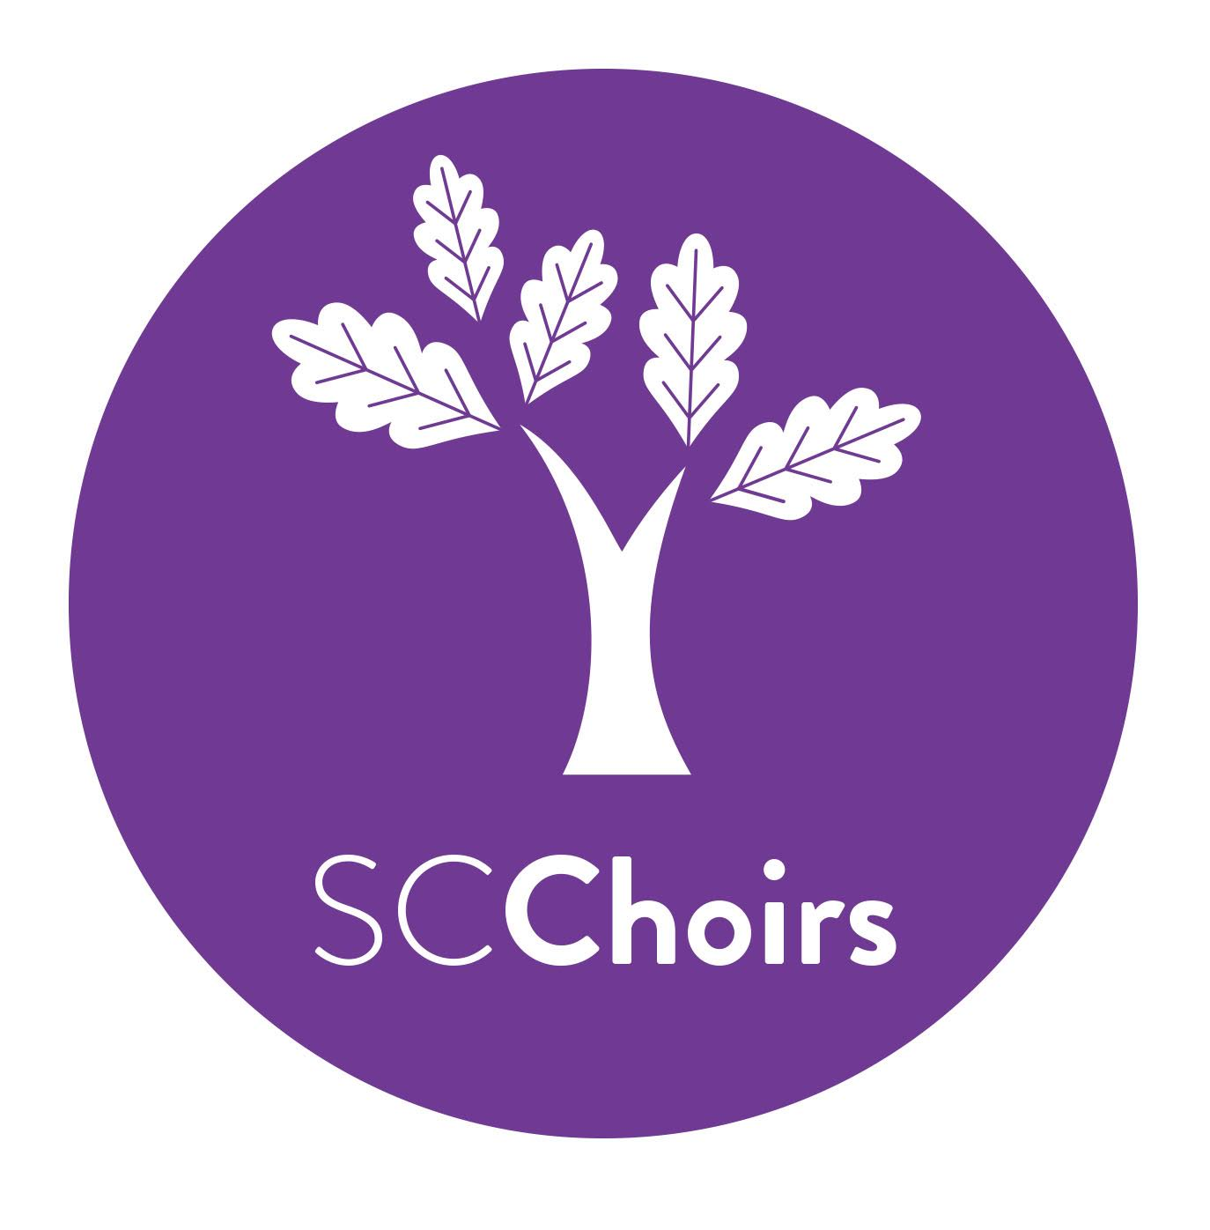
Hosted by singing community of choirs
www.scchoirs.org.uk
2019 SYLLABUS

Sutton Coldfield Festival of Voices
Organised by Singing Community of Choirs, Sutton Coldfield

Saturday, 13th July 2019
Sutton Coldfield Town Hall, Upper Clifton Road, Sutton Coldfield, B73 6AB
Adjudicators : TBC

Please send completed entry forms, fees (cheques made payable to SC Choirs) and, if appropriate, music for accompanist to: Clare Butteriss
20 Bransdale Road
Clayhanger
Walsall WS8 7SD
For Online payments : Lloyds Bank, Sort code 30 65 22, Account No. 80767160. Please add candidate’s full name as a reference followed by FOV.
Enquiries : 07930 564110 / 01543 360430
Email: enquiry@scchoirs.org.uk Website: www.scchoirs.org.uk

Entry fees for all classes £10
Closing date for entries 11th May, 2019

PLEASE READ RULES OVERLEAF PRIOR TO COMPLETING ENTRY FORM

PLEASE READ PRIOR TO COMPLETING ENTRY FORM
- All entries must be accompanied by the entry fee and received before 11th May 2019.
- Copies of music MUST be included with the entry form if our official accompanist is required.
- Backing tracks will not be allowed.
- Official accompanists are provided, if required, for a small fee. However, competitors may bring their own if they wish.
- All dates of birth must be detailed on the entry form for classes where there is a specific age range. The age stated is that of the competitor on the day of the festival.
- No changes will be allowed to the music stated on the entry form.
- In classes where time limits apply, competitors MUST ensure that the entry is within the time limit set. Failure to comply with this will result in only the performance made during the time limit being marked.
- No person may compete more than once in any one class.
- All competitors must be in attendance to compete when called upon. Only in exceptional circumstances can this rule be altered.
- No entry is permissible under an assumed name.
- Order of competing is decided by ballot. The committee reserves the right to alter this if necessary.
- A copy of music must be available for the adjudicators’ use during the class. Please ensure that an original copy is at hand, not a photocopy.
- Entries from professional musicians will not, under any circumstances, be accepted.
- Trophy winners will be required to enter into a bond for safe custody.
- Trophies are to be held until one month prior to the next festival; they are held for one year and cannot be held outright.
- Prize winners must report to the Festival office at the close of the class.
- Protests regarding infringement of any rules must addressed to the festival secretary.
- The committee reserves the right to appoint replacement or additional adjudicators and to alter, modify or cancel any of the arrangements stated in the syllabus.
- THE ADJUDICATORS’ DECISION IS FINAL.
- All teachers, parents or guardians must confirm that our Children and Vulnerable Adults Policy included at the back of the syllabus has been read.
- Winners from each class will be invited to attend the Prizewinner’s Concert in the evening at Sutton Coldfield Town Hall where a prize for the overall winner will be awarded.

Class 1 : Songs from the Shows Age : Under 12 years
Piece : Own Choice
Must not exceed 6 minutes
Prizes : 1st Trophy
2nd Certificate
3rd Certificate

Class 2 : Songs from the Shows - Boys Age : Under 18 years
Piece : Own Choice
Must not exceed 6 minutes
Prizes : 1st Trophy
2nd Certificate
3rd Certificate

Class 3 : Songs from the Shows - Girls Age : Under 18 years
Piece : Own Choice
Must not exceed 6 minutes
Prizes : 1st Trophy
2nd Certificate
3rd Certificate

Class 4 : Songs from the Shows - Men Age : Open
Piece : Own Choice
Must not exceed 6 minutes
Prizes : 1st Trophy
2nd Certificate
3rd Certificate
Class 5 : Songs from the Shows - Ladies Age : Open
Piece : Own Choice
Must not exceed 6 minutes
Prizes : 1st Trophy
2nd Certificate
3rd Certificate

Class 6 : Folk Songs Age : Under 12 Years
Piece : Own Choice
Must not exceed 6 minutes
Prizes : 1st Trophy
2nd Certificate
3rd Certificate

Class 7 : Folk Songs - Boys Age : Under 18 Years
Piece : Own Choice
Must not exceed 6 minutes
Prizes : 1st Trophy
2nd Certificate
3rd Certificate

Class 8 : Folk Songs - Girls Age : Under 18 Years
Piece : Own Choice
Must not exceed 6 minutes
Prizes : 1st Trophy
2nd Certificate
3rd Certificate
Class 9 : Folk Songs - Men Age : Open
Piece : Own Choice
Must not exceed 6 minutes
Prizes : 1st Trophy
2nd Certificate
3rd Certificate

Class 10 : Folk Songs - Ladies Age : Open
Piece : Own Choice
Must not exceed 6 minutes
Prizes : 1st Trophy
2nd Certificate
3rd Certificate

Class 11 : Classical Age : Under 12 Years
Piece : Own Choice
Must not exceed 6 minutes
Prizes : 1st Trophy
2nd Certificate
3rd Certificate

Class 12 : Classical - Boys Age : Under 18 Years
Piece : Own Choice
Must not exceed 6 minutes
Prizes : 1st Trophy
2nd Certificate
3rd Certificate
Class 13 : Classical – Girls Age : Under 18 Years
Piece : Own Choice
Must not exceed 6 minutes
Prizes : 1st Trophy
2nd Certificate
3rd Certificate

Class 14 : Classical – Men Age : Open
Piece : Own Choice
Must not exceed 6 minutes
Prizes : 1st Trophy
2nd Certificate
3rd Certificate

Class 15 : Classical – Ladies Age : Open
Piece : Own Choice
Must not exceed 6 minutes
Prizes : 1st Trophy
2nd Certificate
3rd Certificate

Sutton Coldfield Festival of Voices
Entry Form 2019

Name : ___________________________________________________________________
Address : __________________________________________________________________
Tel. Number : _____________________________ Date of Birth : ___________________
NB Age and date of birth must be given in all classes where there is an age limit.
Please complete the following form with all classes in which you wish to participate, total the cost at the bottom.
ClassNo. |  | Class | Own Choice Music | Composer | Official  Accompanist  Required Y/N |  | Fee
Total Fee to Pay
Please tick the following, as appropriate:
- Cheque, to be sent with the entry form (payable to SC Choirs)
- Online payment (Lloyds Bank, Sort Code 30 65 22, A/C No. 80767160 : Ref. Candidate Name followed by FOV)
- I am happy for SC Choirs to use photographs for the purpose of Festival promotion
- I am happy for SC Choirs to store my personal details for Festival purposes only
- I have read and agree to abide by the Festival Rules and note the contents of SC Choirs’ Vulnerable Adult Policy.

Signed : _____________________________________________Date:____________

Parental signature (under 18s): __________________________Date:_____________

